Title: | LIN Network  SW Component < LIN Network 1.0 >

History
Issue status  (Index) | Maturity/Date  (draft/invalid/valid)  (dd-mmm-yyyy) | Author  Department | Check/Release  Department | Description
1.0 | Draft  29-Nov-15 | Jorge Salas | Benjam{in aguilar | Creation of the document

Table of Contents
1 Purpose 3
2 Definitions and abbreviations 3
3 Realization constraints and targets 3
4 SW Conceptual design 3
5 SW Component internal breakdown 4
5.1 Functional Decomposition 4
5.2 Function <Type> <function name> (type par 1, .., type par n) 5
5.3 Function <Type> <function name> (type par 1, .., type par n) 5

Purpose
This document has been created to explain to design the LIN slave functions that will control a led by the master module.
The slave module must obey four different message types, MASTER_CMD_ALL, MASTER_CMD_SLV3, SLAVE3_RSP and SLAVE3_ID that will be sent by the master module.
After executing the corresponding sequence of commands and specifications defined by the protocol itself, the nodes will control the On-board LEDs of the TRK-MCP5006B Freescale board to display the commands defined in the requirements document, such as ON, OFF and TOGGLING, as well as the node’s own status (enabled/disabled).

Definitions and abbreviations
Definitions
LIN 2.0 | Serial network protocol used for communication between components in vehicles.
Master (Node) | Node chosen to control all communications. Bus arbiter.
Slave (Node) | Node that responds to the master in three possible ways: Receive data, transmit data or ignore data.
LIN | Local Interconnect Network
Rx  Tx  MSTR | Reception  Transmission  Master
SLV | Slave
MSG | Message
CMD  AVT | Command  Advanced Vehicle Technologies

Abbreviations

LIN Local Interconnected Network.
t_slv_stat Signal to display slave node status.
t_cmdType Signal to control LED states and slave node state.
t_LEDstat Signal to display LED status.
t_boolean Signal response that indicates slave node status.
array Signal that contains the team member’s initials for the Msg ID.
scalar Signal that contains the team assigned number for the Msg ID..

References
N° | Document name | Reference
1 | LIN Spec 2-2A
2 | LIN Database Network

Realization constraints and targets

- The master header will be provided by AVT model 718 using the SW tool Generic GUI
- This slave node will listen to all message that correspond at the slave 2
- If the message is MASTER_CMD_ALL the slave will execute the command, the command can be turn on led, turn off led , toggle led, do nothing, enable slave and disable slave (all slaves listen)
- If the message is MASTER_CMD_SLV2 the slave will execute the command, the command can be turn on led, turn off led , toggle led, do nothing, enable slave and disable slave
- If the message is SLAVE2_RSP the slave will publish the led status (on, off, toggle) and the state of the slave (Enable or Disable)
- If the message is SLAVE2_ID the slave will publish the slave2_supplier (in this case the number 2) and the slave2_serial (array with the abbreviation of the names of the team members)
- As mentioned in the requirements, the network counts with 4 slaves modules and shall detect any ID messages but ignore the ones which are not specified for this module.
- It shall be able to detect when it has to send a response and when it has only to perform an action.

SW Conceptual design

Deployment Diagram
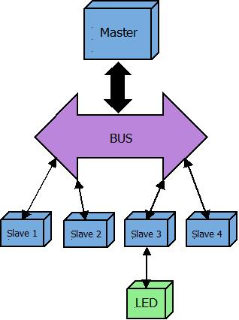

– Use Case Diagram

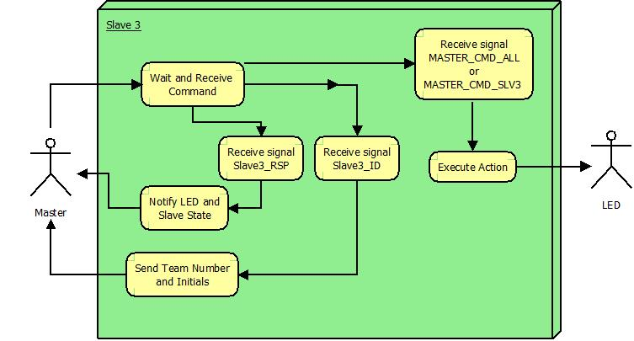

SW Component internal breakdown
For complex SW Components, the designer may define SW Subcomponents. Please consider also the work step "Deal with complexity" provided by the method for Detailed SW Design.
Note: SW Subcomponents are synonymous with the previous used term "Module"
Mapping to the file structure:
- Non complex SW Components should be represented by one object file.
- For complex SW Components each SW Subcomponent should be represented by one object file.
<Subcomponent decomposition if applicable>

Functional Decomposition
Overview of functions and their dependencies shown by a Static Function Tree
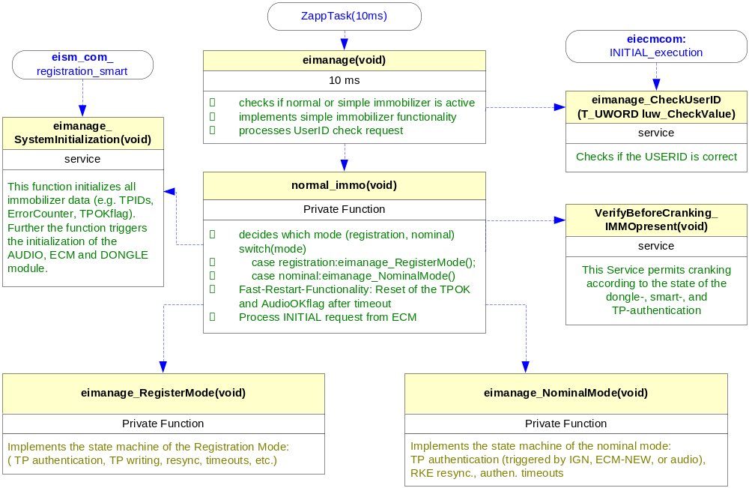
Function Description and Dynamic Behavior
Provide detailed static and dynamic description of all functions of the SW Component.
Functions which are defined in other SW Components shall only be referenced in the external interface description!
The signature description shall be done inside the function header in the source code.
For each function, the following section should be copied

Function <Type> <function name> (type par 1, .., type par n)

Description | Brief description of the function behavior and useful remarks
Parameter 1  <input| output| inout> | Give an explanation if the parameter shall be checked by the user, or if a check is implemented in the function here
Parameter 2..n
Return Value
Precondition | e.g. Function can only be called in a certain state, SW component is initialized  Relation between input parameters where applicable (Input for Module Test)
Post condition | e.g. specific State change e.g. car is locked, EEPROM Values written,  Relation between output parameters where applicable
Error Conditions

Dynamic Behavior
State Chart¹, Flow Chart¹
¹ Preferred
In this document, the dynamic behavior shall be designed on an abstract level showing the principle workflow of a function. Do not show the detailed implementation to ensure that the design description can be maintained with a reasonable effort. The target is not to show the complete detailed implementation 1:1.
The detailed design shall reflect in detail what a function is doing from a black box view. The internal details are useful on an abstract, but not very detailed level.
If the function is not complex a short textual description might be sufficient and a graphical description is not needed.
Symbol and function names shall be self explaining.
The link to the implementation may be provided by using the same names as in the design or by a comment showing the full name followed by the declaration showing the implementation.

Function <Type> <function name> (type par 1, .., type par n)
Description | Brief description of the function behavior and useful remarks
Parameter 1
<input| output| inout>
Parameter 2..n
Return Value
Precondition | e.g. Function can only be called in a certain state, SW component is initialized  Relation between input parameters where applicable (Input for Module Test)
Post condition | e.g. specific State change e.g. car is locked, EEPROM Values written,  Relation between output parameters where applicable
Error Conditions

Dynamic Behavior
State Chart¹, Flow Chart¹, Nassi Shneiderman
¹ Preferred
In this document, the dynamic behavior shall be designed on an abstract level showing the principle workflow of a function. Do not show the detailed implementation to ensure that the design description can be maintained with a reasonable effort. The target is not to show the complete detailed implementation 1:1.
The detailed design shall reflect in detail what a function is doing from a black box view. The internal details are useful on an abstract, but not on a very detailed level.
Symbol and function names shall be self explanatory.
The link to the implementation may be provided by using the same name as in the design or by a comment showing the full name followed by the declaration showing the implementation.

